**Sequence Diagram: Event Filtering**

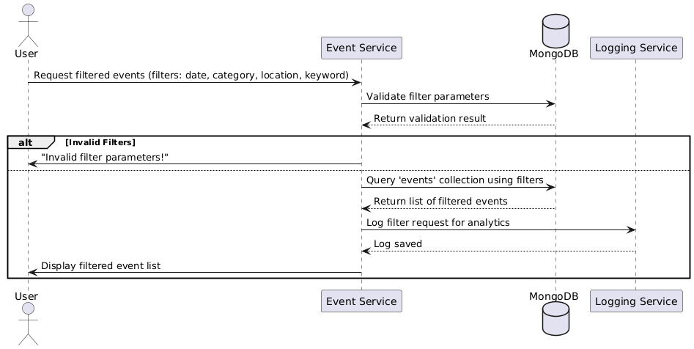

**Database**

**Functional Requirements (FRs)**

* **FR1:** Users shall be able to filter events based on date, category, location, and keywords.
* **FR2**: The system shall validate filter input before querying the database.
* **FR3:** The system shall return a list of matching events**.**
* **FR4:** The system shall allow users to save their preferred filters for quick access.

**Non-Functional Requirements (NFRs)**

* **NFR1:** Filtering operations should return results in less than 1 second.
* **NFR2:** The system should support advanced search indexing for fast query execution.
* **NFR3:** The filtering system should handle at least 500,000 queries per minute during peak load.